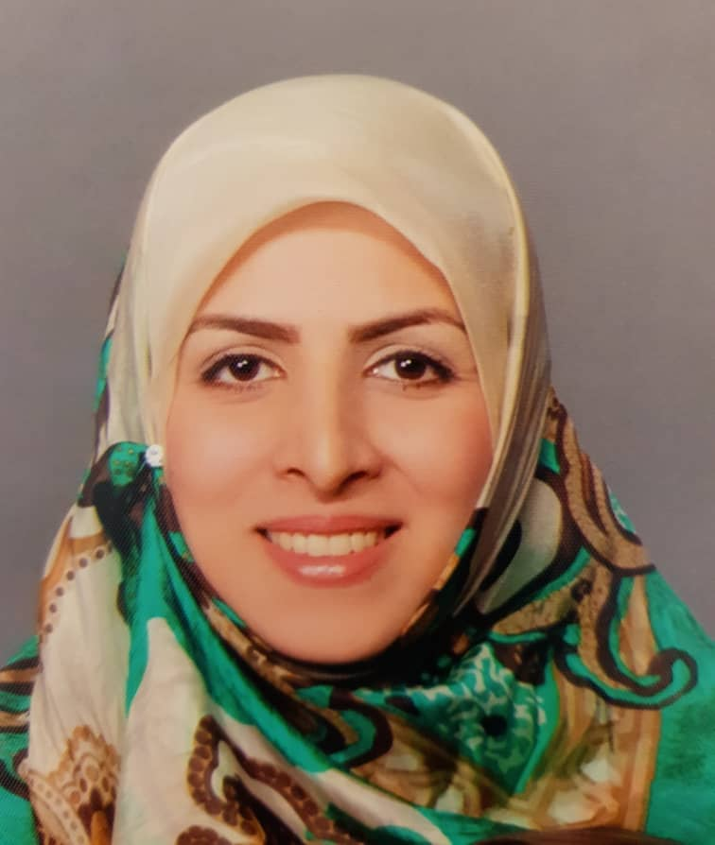
  Marzieh Babaee, MD | DoB: August 12th
  Email: rambabaee@yahoo.com
  Marzieh.babaee@sbmu.ac.ir
  Phone: +9822227021
  Address: EDX part, Mofid Children’s hospital, Shariati St. Tehran, Iran.
Professional Academic Ranks

- Associate professor of Physical Medicine and Rehabilitation, Mofid Children’s hospital, Shahid Beheshti University of Medical Sciences.
- Member of educational committee of TREAT-NMD network
- Member of Directors board of council for rehabilitation, SMA and Cancer rehabilitation committees, (Ministry of medical health and education).
- Vice- Chancellor for research of physical medicine and rehabilitation department. SBMU.
- Vice- Chancellor for research of physical medicine and rehabilitation research center. SBMU
- Assistant Editor of the Iranian Journal of child neurology (Indexed in ISI, Pubmed And Scopus)
- Member of the neuromuscular network of Canada.
- Member of TREAT-NMD Neuromuscular Network.
- Member of Directors board of council for stem cells sciences and technology (presidency of the Islamic Republic of Iran, Vice presidency for science and technology).
- Mentor of physiatrist resident of Shahid Beheshti University of Medical Sciences.
- As a reviewer for pediatric papers in the International Society of Physical and Rehabilitation Medicine congress (ISPRM) 2017.
- A member of the scientific committee, executive committee, and member of national prize committee of the 2nd international festival and congress of stem cell and regenerative medicine.
- As an invited teacher in the rehabilitation School of Arak University of medical sciences.
- As a reviewer in the physical medicine and rehabilitation research center and Iranian Journal of child neurology.

Google H-Index:12
Google G-Index:33
SCOPUS H-Index:10
SCOPUS G-Index:23

Education
- TREAT-NMD (Gene therapy, SMA and DMD) Masterclass, May 2024, Dubai.
- TREAT-NMD Limb Girdle Muscular Dystrophy USA Expert Masterclass, March 2023, North America, Online.
- Myology course of the Institute de Myology of Paris 2021.
- Neuromuscular course in Institute de Myology in Dubai 2019.
- Pediatric rehabilitation observership course in CHEO hospital, Canada, 2017.
- Pediatric rehabilitation observership course in Holland Bloorview hospital, Canada, 2016.
- Board Diploma in Physical Medicine & Rehabilitation, Shahid Beheshti University of medical sciences, Tehran, Iran, 2015.
- M.D, BUMC, Tehran, Iran, 2011.
- Statistical in medicine and scientific writing From Stanford University (US).
- Publishing Connect Author from Elsevier publisher.
- Clinical guideline adaptation and evidenced-based journal club.
- Certification of Write a paper. Publish a paper. Write a systematic review. Peer review and critical appraisal. Knowledge translation and exchange. Evidence-Based Medicine.
- Certificate of mentoring and mentorship.

Language
■ Persian
Reading: Fluent | Writing: Fluent
Speaking: Fluent | Listening: Fluent
■ English
Reading: Fluent | Writing: Fluent
Speaking: Fluent | Listening: Fluent
Selected Publication
Books:

- Pediatric cancer rehabilitation, practical approach, 2024.
- Guide to international standards cares for patients with spinal muscular atrophy (Persian version translated), 2021.
- “Rehabilitation and management of spasticity” chapter of “Neuromodulation and Neurostimulation” book, 2020.
- Platelet rich plasma in orthopedics and sports medicine (Persian translated), 2020.
- Goiter, hyperthyroid and hypothyroid (published in Iran and US), 2008.

Papers:

- A Case Study of Concurrent Parsonage-Turner Syndrome and Ankylosing Spondylitis: Diagnostic and Management Considerations.
Tabibi P, Babaee M, Shiari R, Rehman K, Shiari S. Clin Med Insights Arthritis Musculoskelet Disord. 2025 Feb 23; 18:11795441251320656. doi: 10.1177/11795441251320656. PMID: 40008076; PMCID: PMC11848892.
- Phenotypic and genotyping spectrum of two Iranian cases with RBCK1‐associated polyglucosan body myopathy.
Marzieh Babaee, Yalda Nilipour, Sahar Alijanpour, Aida Ghasemi, Mohammad Mehdi Taghdiri, Payam Sarraf, Mohammad Miryounesi, Mahtab Ramezani. 2025. Neuropathology J. https://doi.org/10.1111/neup.12993
- Drug-Induced Cauda Equina Syndrome in an 8-Year-Old Boy With Acute Lymphoblastic Leukemia: An Uncommon Case Report.
Marzieh Babaee, Mohsen Javadzadeh, Ali Hazeghi. 2025, Clinical Case Report J. https://doi.org/10.1002/ccr3.70122
- Sensory neuropathy in patients with Pompe disease: a case series in Iran.
Babaee, M., Rahmati, M., Dehdahsi, S. et al. BMC Musculoskelet Disord 25, 1078 (2024). https://doi.org/10.1186/s12891-024-08220-4
- Framework and overview of the Pediatric Spinal Muscular Atrophy Registry Program of Iran. Babaee, M., Vahidi Ara, S., Vahidi, H. et al. Egypt J Neurol Psychiatry Neurosurg 60, 153 (2024). https://doi.org/10.1186/s41983-024-00921-w
- Comparative efficacy of risdiplam and nusinersen in Type 2 and 3 spinal muscular atrophy patients: A cohort study using real-world data.
Ashrafi MR, Babaee M, Hashemi Nazari SS, et al. Journal of Neuromuscular Diseases. 2024;11(6):1190-1199. doi:10.1177/22143602241288087
- Safety and efficacy of placental mesenchymal stromal cells-derived extracellular vesicles in knee osteoarthritis: a randomized, triple-blind, placebo-controlled clinical trial.
Najmeh Sadat Bolandnazar, Seyed Ahmad Raeissadat, Hamidreza Haghighatkhah, Seyed Mansoor Rayegani, Rasa Salmani Oshnari, Saeed Heidari Keshel, Mohammad Zahraei, Kianmehr Aalipour, Marzieh Babaee, Amir Zamani, Zahra Besharati Rad, Masoud Soleimani, Farshid Sefat. 25, 856 (2024). https://doi.org/10.1186/s12891-024-07979-w
- What is the Next Step after an Electrodiagnostic Study in Children with Polyneuropathies? Rationale for Laboratory and Other Diagnostic Tests: Approach to children peripheral neuropathy.
Babaee, Marzieh, Urtizberea, J., Fatehi, F., & Rayegani, S. M. (2023). Iranian Journal of Child Neurology, 17(4), 9–22. https://doi.org/10.22037/ijcn.v17i4.43124
- Effects of a multi-component virtual reality program on motor skills and functional postural control in children with hemiplegic cerebral palsy.
Meysam Roostaei, Marzieh Babaee, Seyedmostafa Alavian, Narjes Jafari, Seyed Mansoor Rayegani, Saeed Behzadipour. Heliyon, 2023,9;9
- Neuropsychiatric Manifestations of COVID-19 in Hospitalized Pediatrics: A Multicenter Cross-sectional Study.
Ghazal Zahed, Parvaneh Karimzadeh, Lawrence Sagin Wissow, Soroor Arman, Marzieh Babaee, Reza Shervin Badv, Vahideh Zeinali, Hadi Zarafshan, Shahnaz Armin, Shahram Nasiri, Narges Hashemi, Alireza Moayedi, Collaborating Authors Working Group. Archives of Pediatric Infectious Diseases, 2023, 11;1. DOI: https://doi.org/10.5812/apid-131511
- Efficacy of Duloxetine on electrodiagnostic findings of Paclitaxel-induced peripheral neuropathy, does it have a prophylactic effect? A randomized clinical trial.
Aghabozorgi, Reza; Hesam, Marzieh; Zahed, Ghazal; Babaee, Marzieh; Hashemi, Mahdis; Rayegani, Seyed Mansoor. Anti-Cancer Drugs ():10.1097/CAD.0000000000001429, November 17, 2022. | DOI: 10.1097/CAD.0000000000001429
- Five patients with Spinal muscular atrophy-progressive myoclonic epilepsy (SMA-PME): a novel pathogenic variant, treatment and review of the literature.
Parvaneh Karimzadeh, Hossein Najmabadi, Hanns Lochmuller, Marzieh Babaee, Shima Dehdahsi, Mohammad Miryounesi, Susan Amirsalari, Seyed Mansoor Rayegani, Seyed Hassan Tonekaboni, Neuromuscular Disorders, ISSN 0960-8966, 202 https://doi.org/10.1016/j.nmd.2022.08.002
- Comparison between the effects of ultrasound guided intra-articular injections of platelet-rich plasma (PRP), high molecular weight hyaluronic acid, and their combination in hip osteoarthritis: A randomized clinical trial.
Farshad Nouri, Marzieh Babaee, Parya Peydayesh, Hadi Esmaily, Seyed Ahmad Raeissadat, researchsqure, DOI: https://doi.org/10.21203/rs.3.rs-1374575/v2. 2022/2/24
- Recommendations for Infantile-Onset and Late-Onset Pompe Disease: An Iranian Consensus. Farzad Fatehi, Mahmoud Reza Ashrafi, Marzieh Babaee, Behnaz Ansari, Mehran Beiraghi Toosi, Reza Boostani, Peyman Eshraghi, Atefeh Fakharian, Zahra Hadipour, Bahram Haghi Ashtiani, Hossein Moravej, Yalda Nilipour, Payam Sarraf, Keyhan Sayadpour Zanjani, and Shahriar Nafiss. Front Neurol. 2021;12:739931. Published 2021 Sep 21. doi:10.3389/fneur.2021.739931.
- MRI Changes after platelet rich plasma injection in knee osteoarthritis (A randomized clinical trial).
SA Raeissadat, E Ghorbani, SM Rayegani, M Sanei Taheri, M Babaee, R Soleimani. Journal of Pain Research,13(2020):65
- Role of rehabilitation medicine in the COVID-19 pandemic: an Iranian consensus.
Rayegani, Seyyed M., Seyed A. Raeissadat, Atefeh Fakharian, Marzieh Babaee, Mohammadrasoul Nezamabadi, Najmeh S. Boland Nazar, and Leila Angooti. Eur. j. phys. rehabil. med.(Testo stamp.) (2020).
- Multifocal Neurologic Manifestation of Coronavirus Disease 2019 Infection: Report of 2 Cases. Seyed Manoosr Rayegani, Babak Jalalian, Marzieh Babaee, Fateme Hojjati. Physical Medicine, Rehabilitation, and Electrodiagnosis, 2,1 (2020), 32-34.
- Combination of discrete uniform and shifted binominal model for comparison of the effect of Platelet- Rich Plasma (PRP) and Hyaluronic Acid(HA) on knee osteoarthritis , using WOMAC questionnaire.
Zahra Razaghi, Yadollah Mehrabi, Sedigheh Shams, Marzieh Babaee, Seyed Mansoor Rayegani, Seyed Ahmad Raeissadat. JP Journal of Biostatic, 17(2),2020, 491-501.
- Physical Medicine and Rehabilitation in Iran: The Strength, Weakness, Opportunity, and Threat Matrix Analysis.
Seyed Mansoor Rayegani, Seyed Ahmad Raeissadat, Maryam Seyed-Nezhad, Mohammad Moradi-Joo, Marzieh Babaee, Ali Ayoubian. Physical Medicine, Rehabilitation, and Electrodiagnosis, 2019/9/5.
- Application of platelet-rich plasma and other platelet-derivative products in Iranian studies.
Seyed Ahmad Raeissadat, Marzieh Babaee, Zahra Hashemi. Koomesh, 2019/6/10.
- An overview of platelet products (PRP, PRGF, PRF, etc.) in the Iranian studies.
Raeissadat SA, Babaee M, Rayegani SM, Z Hashemi, AA Hamidieh, P Mojgani, H Fouladi. Future science Journal, 2017 July, 0045.
- Obstacles facing evidence-based medicine in physical medicine and rehabilitation: from opinion and knowledge to practice.
Seyed Ahmad Raeissadat, Mohammad Hasan Bahrami, Seyed Mansoor Rayegani, Hossein Hassanabadi, Marzieh Babaee, Sharif Najafi, Reza Aghabozorgi. Electronic physician, 9(11),2017.
- The effect of scaphoid and hamate mobilization on treatment of patients with carpal tunnel syndrome
Vida Dinarvand, Iraj Abdollahi, Seyed Ahmad Raeissadat, Mohammad Ali Mohseni Bandpei, Marzieh Babaee, Ailin Talimkhani. Anesthesiology and pain medicine, 2017/10
- Attitude, beliefs and knowledge of Iranian physiatrists towards Evidence Based Medicine and its barriers. A cross-sectional study.
SA Raeissadat, MH Bahrami, SM Rayegani, M Babaee, PR Roshanpajouh. European journal of physical and rehabilitation medicine 2016.
- Knee Osteoarthritis Injection Choices: Platelet- Rich Plasma (PRP) Versus Hyaluronic Acid (A one-year randomized clinical trial).
Raeissadat SA, Rayegani SM, Hassanabadi H, Fathi M, Ghorbani E, Babaee M, Azma K.Clin Med Insights Arthritis Musculoskelet Disord. 2015 Jan 7; 8:1-8. doi: 10.4137/CMAMD.S17894. eCollection 2015.
- Does intra articular platelet rich plasma injection improve function, pain and quality of life in patients with osteoarthritis of the knee? A randomized clinical trial.
Rayegani SM, Raeissadat SA, Taheri MS, Babaee M, Bahrami MH, Eliaspour D, Ghorbani E. Orthop Rev (Pavia). 2014 Sep 18;6(3):5405. doi: 10.4081/or.2014.5405. eCollection 2014 Aug 8.
- The effect of platelet-rich plasma on pain, function, and quality of life of patients with knee osteoarthritis.
Raeissadat SA, Rayegani SM, Babaee M, Ghorbani E. Pain Res Treat. 2013;2013:165967. doi: 10.1155/2013/165967. Epub 2013 Dec 9.
- Famotidine in the treatment of functional dyspepsia: a randomized double-blind, placebo-controlled trial.
Amini M, Ghamar Chehreh ME, Khedmat H, Valizadegan G, Babaei M, Darvishi A, Taheri S. J Egypt Public Health Assoc. 2012 Apr;87(1-2):29-33.
- Prevalence of accessory deep peroneal nerve in referred patients to an electrodiagnostic medicine clinic.
Rayegani SM, Daneshtalab E, Bahrami MH, Eliaspour D, Raeissadat SA, Rezaei S, Babaee M. J Brachial Plex Peripher Nerve Inj. 2011 Jul 8;6(1):3.
- Prediction of liver histological lesions with biochemical markers in chronic hepatitis B patients in Iran.
Bashir Hajibeigi Seyed Moayed Alavian, Seyed Hoda Alavian, Neda Ashayeri, Marziyeh Babaei, Maryam Daneshbodi. Gasteroentrology and hepatology from bed to bench, 2010.

Research Projects
1. Evaluation of osteoporosis in SMA patients with different SMN2 copy numbers.
2. Investigation of Charcot-Marie-Tooth disease reports in Iran.
3. Duloxteine effectiveness in improving symptoms of CIPN induced by vincristine in children with cancer.
4. Survival of GBS patients and evaluation of prognostic factors in Mofid Children’s hospital.
5. Evaluation of GBS and thyroid function tests, a systematic review.
6. Fecal incontinence in children registry.
7. Evaluation of polyneuropathy in beta Thalassemia patients.
8. Polyneuropathy type in patients with lead intoxication: a survey study.
9. Foot Drop causes in patients referred to physical medicine and rehabilitation clinics of Shohada-e-Tajrish and Modaress Hospital.

Educational Activities
- Associate professor of physical medicine & rehabilitation, SBMU, 2020-present.
- Teaching course for PMR residents, pediatric neurologist fellows and pediatric rheumatologist fellows. 2020-present.
- Spasticity workshop for physiatrist and pediatric neurologist.
- workshops on platelet rich plasma usage in musculoskeletal disorders at the annual Iranian physical medicine and rehabilitation congress, neuromusculoskeletal congress and 2nd international festival and congress of stem cell and regenerative medicine.
- Osteoporosis, Hemophilia rehabilitation and cancer rehabilitation workshop for physicians of Arak university of medical sciences.
- lectures and 6 posters in international physical medicine and rehabilitation congresses
- lecture in international TREAT-NMD conference
- lectures and 7 posters in Iranian annual physical medicine and rehabilitation congresses
- lectures in Neurometabolic conferences
Honors/Awards

- MD in general Medicine: the recognized talents (2011).
Innovations
- A wearable device that can vibrate and simultaneously electrically stimulate body muscles, 2023
Interested Research Fields
- Neuromuscular and neurometabolic disorders.
- Pediatric Rehabilitation and neurorehabilitation.
- SMA, DMD, neuropathy management and treatment in children.
- Regenerative medicine.
Hobbies

- Swimming
- Cooking
- Adventure

