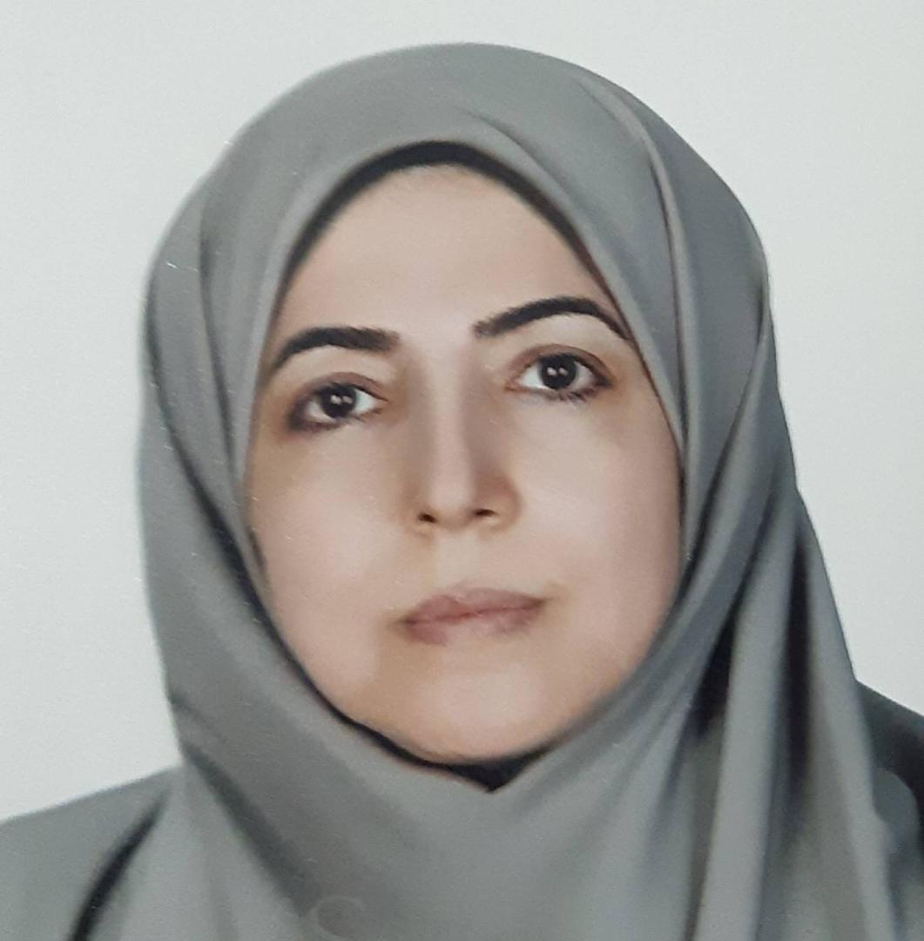
  Zahra Rezasoltani, MD | DoB: 16/05/1989
  Email: Z.rezasoltani@ajaums.ir
  Phone: +989123947633
  Address: Physical Medicine & rehabilitation Department. Fatemi Street. Etemadzade Avenue . Tehran . Iran
Professional Academic Ranks

- Full Professor of Physical Medicine and Rehabilitation (AJA University of Medical Sciences)

Google H-Index: 15

Education

- MD, Isfahan University of Medical Sciences, Isfahan, Iran, 1988-1995
- Physical Medicine & Rehabilitation specialty, AJa university of Medical Sciences, Tehran,Iran, 1998-2001
- Member of Clinical Biomechanics & Ergonomics Research center of Aja university of Medical Sciences, 2012- contd.
- Member of Physical Medicine & Rehabilitation research center of Shahid Beheshti university of Medical Sciences, 2015-contd.

Language
■ Persian
Reading: Fluent | Writing: Fluent
Speaking: Fluent | Listening: Fluent
■ English
Reading: Fluent | Writing: Fluent
Speaking: Fluent | Listening: Fluent

Selected Publications

■ Papers
1- Efficacy of Tele- rehabilitation compared with office – board physical thrapy in Patients with knee Osteoarthritis : A randomized clinical Trial.
Kamran Azma, Zahra RezaSoltani, Farid Rezaeimoghaddam, Afsaneh Dadarkhah and Sarasadat Mohsenolhosseini
Journal of Telemedicine and Telecare 2017
2- Peri articular Dextrose Prolothrapy instead of intra articular injection for pain & functional improvement in knee Osteoarthritis .
Zahra Rezasoltani, Mehrdad Taheri, Morteza Kazempour Mofrad , Seyed Amir Mohajerani
Journal of Pain research 2017
3- Low level Laser Therapy Versus Local Steroid Injection in Patients With idiopathic Carpal Tunnel Syndrome : A single blind randomized comparative trial
Zahra RezaSoltani- Mahsa Asheghan-Ahmad Raies Sadalt , Ali Asghar Ghayyomi, Kamran Azma
Internet Journal Of Medical update . 8(2):21-28 2013
4- Study of Long Term Effects Of Laser Thrapy Versus Local Steroid Injection in Patient With Carpal Tunnel Syndrome
Raeissadat Ahmad , Reza soltani Zahra
Journal of Lasers in medical Sciences – Autumn 2010 – Vol 1 – Num 1
5- F- Wave to height or limb Length ratios rational alternatives for F-Wave Latency in Clinical electrodiagnostic Medicine
Hooman Mahmoudi, Zahra salehi, Kamran Azma, , Zahra RezaSoltani, Mohammad reza Omidzohour
Clinical Neurophysiology.122(2011)2300-2304
6- Sjogren – Larsson Syndrome in two brothers: A case report
Farid Rezai Moghaddam , Farid Safar, Mahsa Asheghan , Zahra RezaSoltani, Fatemeh Dehghanzade
Cases Journal (2009).
7- A comparison Of Magnetic resonance imaging with electrodiagnostic findings in the evaluation of clinical radiculopathy: A cross Sectional Study
Zahra RezaSoltani, Simin Sajadi, Behrooz Tavana.
European Spine Journal (2013)
8- Comparison of Pressure on different Areas of the foot in military and Non- Military Patients with diabetes Referred to a Hospital
Radina Eshtiaghi, Zahra RezaSoltani(corresponding author) ,Alireza Esteghamati,Manouchehr Nakhjavani, , Amir Eslami
Biosciences , Biotechnology Research Asia. Vol (11) .No(4).2015
9- The frequency of knee joint injuries caused by sport activities among the armed forces personel
Zahra Rezasoltani, Faeze Dehghan, Ali Azizan, Afsaneh Dadarkhah, Farhad Yadegarian
Journal of archives military medicine, Published online. September 2016 .
10-Physical therapy, intra-articular dextrose prolotherapy, botulinum neurotoxin and hyaluronic acid for knee osteoarthritis : Randomized clinical trial
Rezasoltani.Z ,Azizi.S ,Najafi.S, Sanati.E, Dadarkhah.A, Abdorrazaghi.F
International journal of Rehabilitation Research . vol 43.September 2020.
11-Intra-articular botulinum toxin type A for treatment of knee osteoarthritis: clinical trial
Najafi.S, Sanati.E, Khademi.M, Abdorrazaghi.F, Morad.R.K, Rezasoltani.Z (corresponding author)
Toxicon .vol 165, July 2019
12-Transcranial direct current stimulation for knee osteoarthritis : a sigle blind randomized sham controlled trial
Azizi.S ,Rezasoltan.Z, Najafi.S, Mohebi.B,Tabatabaee.S.M, Dadarkhah.A
Neurophysiologie Clinique .vol 51,August 2021
13-Therapeutic effect of intra-articular botulinum neurotoxin versus physical therapy in knee osteoarthritis
Rezasoltani.Z, Dadarkhah.A, Tabatabaee.S.M, Mofrad.R.K, Abdorrazaghi.F
Anesthesiology and pain Medicine.2021
14-High versus low molecular weight Hyaluronic Acid for the treatment of Rotator Cuff tendinopathy : A triple blind Randomized Comparative Trial
Mohebi.R, Rezasoltani.Z, Mir.M, Esmaily.H, Vatandoost.S.
Annals of pharmacotherapy.2021
15- Low molecular weight Hyaluronic Acid versus physiotherapy for the treatment of supraspinatus tendinopathy : A randomized comparative clinical trial
Rezasoltani.Z, Esmaily.H, Dadarkhah.A, Mohebi.R, Vashaei.F
Journal of the American Academy of orthopaedic surgeons.2021
16-Randomized controlled Trial of Aquatic cycling for treatment of knee osteoarthritis in elderly people
Rezasoltani.Z , Sanati.E, Kazempour Mofrad.R, Dadarkhah.A, Najafi. S.
Topics in Geriatric Rehabilitation.2020
17-Biofeedback versus electrical stimulation for sexual dysfunction :A Randomized clinical trial
Alaie. B, Tavana.B, Rezasoltani.Z, Ghaderi.J, Dadarkhah. A
International Urogynecology Journal. 2021
18- Spinal manipulation for subacute and chronic lumbar radiculopathy : A Randomized controlled trial
Ghasabmahaleh.S.H, Rezasoltani.Z, Dadarkhah.A, Morad.R.K, Najafi.S.
American Journal of Medicine.2021
19-Periarticular Neurofascial Dextrose prolotherapy versus physiotherapy for the treatment of chronic Rotator Cuff Tendinopathy: Randomized Clinical Trial
Kazempour Mofrad. M, Rezasoltani .Z(corresponding author), Dadarkhah.A.Kazempour Mofrad.R ,Abdorrazaghi.F, Azizi.S.
Journal of Clinical Rheumatology.2021
20-Randomized Controlled Trial of aquatic exercise for treatment of knee osteoarthritis in elderly people
Azizi.S, Dadarkhah.A, Rezasoltani.Z, Mofrad.R.K, Najafi.S
Interventional Medicine and Applied Science.2020
21-Granisetron vs. lidocaine injection to trigger points in the management of myofascial pain syndrome: A double- blind Randomized clinical trial
Rezasoltani.Z ,Ehyaie.H, Mofrad.R.K, Mohtasham.R, Najafi.S
Scandinavian journal of Pain.2021
22-Remote versus in-person exercise instruction for chronic non specific low back pain lasting 12 weeks or longer : A Randomized Clinical Trial
Dadarkhah.A, Rezaimoghadam.F, Najafi.S, Azarakhsh.A, Rezasoltani.Z
Journal of National Medical Association.2021
23-effects of aerobic exercise on electrophysiologic features of Diabetic peripheral Neuropathy : Single-Blind Clinical Trial
Azizi.S, Najafi.S, Rezasoltani.Z, Zamani.N, Dadarkhah.A
Topics in Geriatric Rehabilitation.2019
24-Neurofascial Dextrose prolotherapy for managing chronic ankle ligament injury
Mofrad.R.K, Rezasoltani.Z, Dadarkhah.A, Tabatabaee. S.M, Azarakhsh.A
Anesthesiology and pain Medicine.2022
25-H- Reflex attenuation after lumbosacral manipulation in patients with low back pain
Azadvari.M, Emami Razavi.S.Z, Rezaiee Moghaddam.F, Rezasoltani.Z, Azizi.S, Rakhshan.A
Acta Medica Iranica.2018
26-Transcranial direct current stimulation for nonspecific low back pain :Double- blind randomized sham controlled trial
Rezasoltani.Z, Azizi.S, Najafi.S, Sedighi.S, Movahed.M.E,Dadarkhah.A
Rehabilitacja Medyczna.2019
27-Non-local muscle fatigue is mediated at spinal and supraspinal levels
Amiri.E, Gharakhanlou.R, Rajabi.H, Rezasoltani.Z, Azma.K
Expermental Brain research.2022
28-The effect of NaY nano-Zeolite on the mechanical properties of Silicon insoles
Mortazavi.S.M, Najafi.S, Rezasoltani.Z, Ghashang.M, Hami.Z
Silicon.2022
29-Comparison of knee valgus angle and postural sway in two conditions with and without carrying a Military Backpack between Military with and without patellofemoral pain syndrome
Mansourizadeh.R, Rezasoltani.Z,Dadarkhah.A
Journal of Military Medicine.2023
30-Platelet- rich plasma therapy or arthroscopic surgery on repair of anterior cruciate ligament rupture
Eslami.S, Fattah.S, Alimohammadzadeh Taher.S, Rezasoltani.Z
European Journal of Translational Myology. 2022
31-Subacromial injections of low or high molecular weight Hyaluronate versus physical therapy for shoulder Tendinopathy : A Randomized Triple-Blind Controlled Trial
Esmaily.H, Mohebbi.R, rezasoltani.Z (corresponding author), Dadarkhah.A, Mir.M
Clinical Journal of Sport Medicine.2022
32-The effect of Stem on the knee joint prosthesis Flexion considering natural Gait Forces
Soltani.N, Rezasoltani.Z, Jamshidi.N
27 th National and 5 th International Iranian conference OF Biomechanical Engineering ,ICBME 2020 (conference Abstract)
33- Relationship between neuropathy with pressure on foot in diabetic patients
Eshtiaghi.R, Rezasoltani.Z corresponding author), Esteghamati.A, Nakhjavani.M, Eslami.A
Biomedical and Pharmacology Journal.2015
34-Bilateral responses of terapezius muscle to transcranial magnetic stimulation in normal subjects
Tavana.B, Dehghanizade.F, Rezasoltani.Z, Asheghan.M, Najafi.S.H
Koomesh.2008
35-Comparative study of central motor conduction time by using magnetic stimulation and F-wave study in normal subjects
Rezasoltani.Z, Tavana.B, Asheghan.M, Dehghanizade.F
Koomesh.2007
36-The association of quality of sleep with reaction time and aiming accuracy in healthy young adults
Rezasoltani.Z, Dadarkhah.A, Najafi.S, Sanati.E, Mofrad.R.K
Sleep and Hypnosis.2019
37-Effect of a course of Resistance training and neurofeedback on supraspinal nerve function and shooting score of Beginner Militaries
Ahmadreza Yousefpour Dehaghani, Hamid Rajabi, Lida Moradi, Zahra RezaSoltani, Dariush Eliaspour
Journal of Military Medicine.vol 25.2024
38-Comparison of the lumbosacral manipulation method versus knee exercises alone in patients with patellofemoral pain syndrome
S .Azizi, Z .Rezasoltani , E. Shirzadi, A Dadarkhah, M Elahi
Journal of Archives in Military Medicine.2020
39-Transcranial Direct Current Stimulation Efficacy on pain and quality of life of patients with Fibromyalgia Syndrome
A Dadarkhah, Z Rezasoltani, FR Moghadam, E Shirzadi,M Elahi
JPMRE.2020
40-Comparison of the effect of Hip ,Knee and Ankle Fatigue on Dynamic Balance of Armed Forces
Z Rezasoltani , MB Chadegani, A Azarakhsh, L Yarmohammadi
JPMRE.2020
41-Long- Term Efficacy of Dextrose Prolotherapy versus Hyaluronic Acid in knee osteoarthritis
Z Rezasoltani , M Bahrami-Asl, M Bagheri, S Azizi, S Hamidipanah
JPMRE.2020
42-Investigating The effect of a sacroiliac belt on the kinematic of trunk , pelvis and Hip joints in Military personnel suffering from sacroiliac joint pain and healthy Military…
Z Rezasoltani ,MB Chadegani, A Azarakhsh, L Yarmohammadi
JPMRE.2020
43-The relationship between dorsal spine dysfunction and Gastrointestinal pain and the efficacy of manipulation on them
S Azizi , Z Rezasoltani ( corresponding author ), S Najafi, K Azma, S Hamidipanah, A Dadarkhah
JPMRE.2020
44-Evaluation of Repetitive Transcranial Magnetic Stimulation on the pain of patients with Fibromyalgia
Z Rezasoltani ,S azizi, S Najafi, A Dadarkhah, S Hamidipanah, M Abedi
JPMRE.2019
45-Efficacy of oral Alendronate versus Zoledronic Acid on postmenopausal osteoporosis
S Najafi, Z Rezasoltani, K Azma, SN Abbas, M Aghaei, E Sanati
Annals of Military and Health Sciences Research.2019
46-The effect of strengthening exercises of the Hip extensor and external rotator muscles on patellofemoral pain syndrome
S Azizi, M Elahi, A Dadarkhah, E Shirzadi, Z Rezasoltani,F Abdorrazaghi
JPMRE.2019
47-The effect of upper limb exhaustive activity on corticospinal excitability and motoneuron responsiveness of lower limb
A Kavehee, R Gharakhanlou, H Rajabi, Z Rezasoltani, K Azma, E Amiri
Sport Physiology.2019
48-Effects of mechanical low back pain in spatiotemporal parameters of gait
S Najafi , Z Rezasoltani, M Abedi
Journal of Archives in Military Medicine.2018
49-Changes in corticospinal excitability and motoneurons responsiveness during and within a time-course after submaximal fatiguing contractions
E Amiri , R Gharakhanlou ,Z Rezasoltani, K Azma, A Kavehee
Sport Physiology.2018
50-Investigation of relationship between psychological risk factors and neuropathy with pressure on different areas of the foot in diabetic patients referred to a hospital in…
R Eshtiaghi, Z Rezasoltani ( corresponding author), A ESteghamati, M Nakhjavani, A Eslami
Bioscience , Biotechnology ResearchAsia .2015
51- The comparison of Shock wave therapy and Corticosteroid injection on the treatment of plantar Fascitis
Z Rezasoltani, S Najafi, S Azizi, B Forough, H Fateh
Annals of Military and Health Sciences Research.2013
52-Local Corticosteroid injection and low level laser therapy (LLLT) in the treatment of Lteral Epicondylitis : A Comparative study
F Rezaeemoghadam, B Tavana,Z Rezasoltani, K Azma,M Kazemi
HBI_ Journals.2008
53- Effects of Calcium Carbonate on pain symptoms in third trimester of pregnancy and nursing period : A Randomized clinical trial
SA Taher, Z Rezasoltani
Journal of Family and Reproductive Health.2008
54- Case report : Refsum,s disease
K Azma, SZ Reza, M Asheghan, L Etefagh, A Ghayoumi, EM Nasr
Educational Activities
- Teaching Physical Medicine & Rehabilitation at Aja university of Medical Sciences, Department of Physical Medicine & Rehabilitation
- Faculty Member of Physical Medicine & Rehabilitation Department of Aja university of Medical Sciences
Attended workshops
- Research Methodology : 2001
- Method of thinking : 2015
- Professional Ethics :2015
- Clinical Competency Assessment (PMP) : 2015
- Self care & Family Health :2015
- Scientific Paper writing : 2017
- Review of Medical Papers: 2017
- ICMM: 2017
- SPSS: 2015
- Exam Designing: 2015
Lectures

1-Neuro fascial Prolotherapy as a new treatment for varieus Musculoskeletal conditions.
19th Annual Iranian congress of physical Medicine & Rehabilitation .3-5 feb . 2016
2- Evaluation of the Effect of TDCS on choice nonspeciafic Low back pain.
Iranian International Neurorehabilitation Congress Tehran-Iran. 16-18 Ocrober 2016
3- Evidence Bassed intraarticular injections in Knee Osteoarthritis 20th Annual Congress of Iranian Society of Physical Medicine & Rehabilitation 1-3 March 2017.
4- Prolothrapy application in physical Medicine & Rehabilitation
15th congress of physical Medicine & Rehabilitation – shahid beheshti university of Medical Sciences 2011
5- Prolothrapy treatment in chronic Low back pain
15th congress of physical Medicine & Rehabilitation – shahid beheshti university of Medical Sciences 2011
6- Effect of Spinal Manipulation on tibial H_ Reflex.
16th congress of physical Medicine & Rehabilitation Aja of university of Medical Sciences.
7- Trans cranial direct current stimulation for the treatment of chronic pain - 2012
16th congress of physical Medicine & Rehabilitation Aja of university of Medical Sciences.
8- The comparison of shock wave therapy & cortico steroid injection on the treatment of Plantar fasciitis.
16th congress of physical Medicine & Rehabilitation Aja of university of Medical Sciences 2012
9- Acupanctare in complex regional pain Syndrome.
16th congress of physical Medicine & Rehabilitation Aja of university of Medical Sciences 2012
10- Time sequence of hyalgan Effects in knee OA.
17th congress of physical Medicine & Rehabilitation- Iran university of Medical Sciences.
11- Myofacial Pain syndrome
First congress of Neuro musculskeletal disorders – Mazandaran university of Medical Sciences 2010
12- Cervial Causen of headache , Diagnisis & Pathophysiology – Tehran university of Medical Sciences- 2010
13- Post Traumatic syringomyelia as a common Cause of Neurogenic declin and functional loss after SCI – university of walfare & Rehabilitation Sciences- 2003
14- Extra articular Prolothrapy as an adjuvant treatment in knee OA.
shahid Beheshti university of Medical Sciences.2014
Honors/Awards
- Ranked first place in physical Medicine & Rehabilitation Board certification exam (2001)
- Honored Young researcher of Aja university of Medical Sciences (2004)
- Honored University Professor in Physical Medicine and Rehabilitation (2003 and 2008 )
Hobbies
- Travelling
- Mountain Climbing
- Playing Piano
- Reading

